Acknowledgment 3

Project Overview 3

Business Research 3

INTERVIEW 3

COMMUNICATE WITH SENIORS 4

SEARCH IN INTERNET 4

Technical Research 4

W3SCHOOLS 4

TUTORIALS POINT 4

STACK OVERFLOW 5

Technology Used 5

JAVA EE PLATFORM 5

HTML5 5

JAVA SCRIPT 6

CSS3 6

MYSQL 7

HIBERNATE 7

GOOGLE MAP SERVICE 8

Software Tools & IDEs 8

NETBEANS 8

MYSQL WORKBENCH 8

DESIGN 8

DEVELOP 9

ADMINISTER 9

VISUAL PERFORMANCE DASHBOARD 9

DATABASE MIGRATION 9

ADOBE PHOTOSHOP 10

ADOBE DREAMWEAVER 11

FIREFOX (WEB-BROWSER) 11

CHROME (WEB-BROWSER) 12

GLASSFISH SERVER 4.1 12

Use Case Diagrams 13

Buyer 13

Admin 14

Super Admin 14

Advertiser 15

Activity Diagrams 16

User Registration 16

Account Activation 17

Search Product 18

Product Rating 19

Add to Cart 20

Purchase Cart 21

Product Reorder 22

Interfaces 23

Home 23

User Registration 24

Login 24

Product Details 25

Account Verification 25

Cart 26

Search & Advanced Search 26

Purchase Summary 27

Profile 28

Basic information 28

View Invoice 28

Admin Panel 29

Product Registration 29

Vendor Management 29

Advisors 30

Create Ads 30

View Ads 30

Stock Management 31

Advertisement Management 31

Entity Relationship Diagram 32

# Acknowledgment

First of all, I would like to thank to All lectures (Mr.Pradeep, Mr. Janith, Mr.Isuru, Mr.Kanishka, and Mr.Amila) of IJTS for the valuable guidance and advice for the success for this project. They inspired us greatly to work in this project. His willingness to motivate us contributed tremendously to my project. I also would like to thank them for showing me some example that related to the topic of our project.

Besides, I would like to thank the authority of Institute for advanced java technological Studies (IJTS) for providing us with a good environment and facilitate to complete this project. Also, I would like to take this opportunity to thank to the AJDES practical program for offering this subject, computing project.

Finally, an honorable mention goes to our friends and all persons who help me to success this project by giving details and for their understanding support on us in completing this project.

# Project Overview

Out there a lot of business opportunities available in various type of fields. All are depend on people’s day to date needs, government action, education purpose and the evolution of new technologies. As the daily of updating of new technologies people’s needs have been change.   
So I found a way to full fill these human needs by choosing a particular filed which is delivering flowers to various ceremonies. Because of the busy schedule of people they do not have time to visit a flowers shop or choose spend time to choose gifts so I took this as opportunity and build a **web-site** call *Royal Flowers* which is selling Artificial Flowers online.

It will help to people to come online and choose flowers in many different categories and send them over to their families and friends. It save their time and waste. It call it click distance to the shop and we can call it e-commerce.

# Business Research

## INTERVIEW

An **interview** is a conversation between two or more people where questions are asked by the interviewer to elicit facts or statements from the interviewee. Although interviews are a standard part of journalism and media reporting, the focus of this piece is on how interviews can be used as a tool for psychological research

## COMMUNICATE WITH SENIORS

We could get lot of advices and ideas from our seniors. It is very useful because they have lot of experience and practical knowledge. So we could get help from them for problems we had to face during the project.

## SEARCH IN INTERNET

Internet researching is good method for doing a business research. Because internet like space. There are no boarders and we can search anything we want from there. But compare with other it is not good for students because we can’t get experience from there. So we don’t use internet so much for this project.

# Technical Research

## W3SCHOOLS

W3Schools is a web developers site, with tutorials and references on web development languages such as HTML, CSS, JavaScript, PHP, SQL, and JQuery, covering most aspects of web programming.

The site derives its name from the World Wide Web (W3), but is not affiliated with the W3C.

W3Schools was originally created in 1998, by Refsnes Data, a Norwegian software development and consulting company.

Try it out here :   
**<a href="http://www.w3schools.com/">W3Schools.com</a>**

## TUTORIALS POINT

20 million readers read 50 million pages every month

Tutorials Point originated from the idea that there exists a class of readers who respond better to online content and prefer to learn new skills at their own pace from the comforts of their drawing rooms.

The journey commenced with a single tutorial on HTML in 2006 and elated by the response it generated, we worked our way to adding fresh tutorials to our repository which now proudly flaunts a wealth of tutorials and allied articles on topics ranging from programming languages to web designing to academics and much more.

[**http://tutorialspoint.com/**](http://tutorialspoint.com/)

## **STACK OVERFLOW**

is a question and answer site for professional and enthusiast programmers. It's built and run by you as part of the [Stack Exchange](http://stackexchange.com) network of Q&A sites. With your help, we're working together to build a library of detailed answers to every question about programming.

[**Http://stackoverflow.com**](Http://stackoverflow.com)

# Technology Used

## JAVA EE PLATFORM

**Java Platform, Enterprise Edition** or **Java EE** is a widely used enterprise computing [platform](https://en.wikipedia.org/wiki/Platform_%28computing%29) developed under the [Java Community Process](https://en.wikipedia.org/wiki/Java_Community_Process). The platform provides an [API](https://en.wikipedia.org/wiki/API) and runtime environment for developing and running [enterprise software](https://en.wikipedia.org/wiki/Enterprise_software), including [network](https://en.wikipedia.org/wiki/Network_service) and [web services](https://en.wikipedia.org/wiki/Web_service), and other large-scale, multi-tiered, scalable, reliable, and secure network applications. Java EE extends the [Java Platform, Standard Edition](https://en.wikipedia.org/wiki/Java_Platform,_Standard_Edition) (Java SE),[[1]](https://en.wikipedia.org/wiki/Java_Platform,_Enterprise_Edition#cite_note-1) providing an API for [object-relational mapping](https://en.wikipedia.org/wiki/Object-relational_mapping), [distributed](https://en.wikipedia.org/wiki/Distributed_computing) and [multi-tier architectures](https://en.wikipedia.org/wiki/Multitier_architecture), and [web services](https://en.wikipedia.org/wiki/Web_services). The platform incorporates a design based largely on [modular](https://en.wikipedia.org/wiki/Modularity_%28programming%29) [components](https://en.wikipedia.org/wiki/Software_component) running on an [application server](https://en.wikipedia.org/wiki/Application_server). Software for Java EE is primarily developed in the [Java](https://en.wikipedia.org/wiki/Java_%28programming_language%29) programming language. The platform emphasizes [convention over configuration](https://en.wikipedia.org/wiki/Convention_over_configuration)[[2]](https://en.wikipedia.org/wiki/Java_Platform,_Enterprise_Edition#cite_note-2) and [annotations](https://en.wikipedia.org/wiki/Java_annotation) for configuration. Optionally [XML](https://en.wikipedia.org/wiki/XML) can be used to override annotations or to deviate from the platform defaults.

## HTML5

**HTML5** is a [markup language](https://en.wikipedia.org/wiki/Markup_language) used for structuring and presenting content on the [World Wide Web](https://en.wikipedia.org/wiki/World_Wide_Web). It was finalized, and published, on 28 October 2014 by the [World Wide Web Consortium](https://en.wikipedia.org/wiki/World_Wide_Web_Consortium) (W3C). This is the fifth revision of the [HTML](https://en.wikipedia.org/wiki/HTML) standard since the inception of the World Wide Web. The previous version, HTML 4, was standardized in 1997.

Its core aims are to improve the language with support for the latest multimedia while keeping it easily readable by humans and consistently understood by computers and devices ([web browsers](https://en.wikipedia.org/wiki/Web_browser), [parsers](https://en.wikipedia.org/wiki/Parsing), etc.). HTML5 is intended to subsume not only [HTML 4](https://en.wikipedia.org/wiki/HTML_4), but also [XHTML](https://en.wikipedia.org/wiki/XHTML) 1 and [DOM Level 2 HTML](https://en.wikipedia.org/wiki/Document_Object_Model).

more Reading : <https://en.wikipedia.org/wiki/HTML5>

## JAVA SCRIPT

**JavaScript**® (often shortened to **JS**) is a lightweight, interpreted, object-oriented language with [first-class functions](https://en.wikipedia.org/wiki/First-class_functions), and is best known as the scripting language for Web pages, but it's [used in many non-browser environments](https://en.wikipedia.org/wiki/JavaScript#Uses_outside_web_pages) as well. It is a [prototype-based](https://en.wikipedia.org/wiki/Prototype-based_programming), multi-paradigm scripting language that is dynamic, and supports object-oriented, imperative, and functional programming styles.

JavaScript runs on the client side of the web, which can be used to design / program how the web pages behave on the occurrence of an event. JavaScript is an easy to learn and also powerful scripting language, widely used for controlling web page behaviour.

more reading : <https://developer.mozilla.org/en-US/docs/Web/JavaScript/About_JavaScript>

## CSS3

A web page consists of markup—HTML (HyperText Markup Language) that describes the meaning of the content on the page—and CSS (Cascading Style Sheets) that tell the browser how the content should be displayed in browsers and other user agents that need to display it. CSS tells the browser everything from the layout of the page to the colors of your headings.

CSS3 is the latest version of the CSS specification. The term “CSS3” is not just a reference to the new features in CSS, but the third level in the progress of the [CSS specification](http://www.w3.org/Style/CSS/current-work.en.html). CSS3 contains just about everything that’s included in CSS2.1 (the previous version of the specification). It also adds new features to help developers solve a number of problems without the need for non-semantic markup, complex scripting, or extra images.

Features that are included in CSS3 include support for additional selectors, drop shadows, rounded corners, multiple backgrounds, animation, transparency, and much more.

more reading : <http://www.sitepoint.com/web-foundations/what-is-css3/>

## MYSQL

**MySQL** (officially pronounced as [/maɪ ˌɛskjuːˈɛl/](https://en.wikipedia.org/wiki/Help:IPA_for_English) "My S-Q-L",) is an [open-source](https://en.wikipedia.org/wiki/Open-source) [relational database management system](https://en.wikipedia.org/wiki/Relational_database_management_system) (RDBMS);in July 2013, it was the world's second most widely used RDBMS, and the most widely used open-source [client–server model](https://en.wikipedia.org/wiki/Client%E2%80%93server_model) RDBMS.It is named after co-founder [Michael Widenius](https://en.wikipedia.org/wiki/Michael_Widenius)'s daughter, My.The [SQL](https://en.wikipedia.org/wiki/SQL) acronym stands for [Structured Query Language](https://en.wikipedia.org/wiki/Structured_Query_Language). The MySQL development project has made its [source code](https://en.wikipedia.org/wiki/Source_code) available under the terms of the [GNU General Public License](https://en.wikipedia.org/wiki/GNU_General_Public_License), as well as under a variety of [proprietary](https://en.wikipedia.org/wiki/Proprietary_software) agreements. MySQL was owned and sponsored by a single [for-profit](https://en.wikipedia.org/wiki/Business) firm, the [Swedish](https://en.wikipedia.org/wiki/Sweden) company [MySQL AB](https://en.wikipedia.org/wiki/MySQL_AB), now owned by [Oracle Corporation](https://en.wikipedia.org/wiki/Oracle_Corporation).For proprietary use, several paid editions are available, and offer additional functionality.

MySQL is a popular choice of database for use in web applications, and is a central component of the widely used [LAMP](https://en.wikipedia.org/wiki/LAMP_%28software_bundle%29) open-source web application software stack (and other "[AMP](https://en.wikipedia.org/wiki/List_of_AMP_packages)" stacks). LAMP is an acronym for "[Linux](https://en.wikipedia.org/wiki/Linux), [Apache](https://en.wikipedia.org/wiki/Apache_HTTP_Server), MySQL, [Perl](https://en.wikipedia.org/wiki/Perl)/[PHP](https://en.wikipedia.org/wiki/PHP)/[Python](https://en.wikipedia.org/wiki/Python_%28programming_language%29)". [Free-software](https://en.wikipedia.org/wiki/Free_software) open-source projects that require a full-featured database management system often use MySQL. Applications that use the MySQL database include: [TYPO3](https://en.wikipedia.org/wiki/TYPO3), [MODx](https://en.wikipedia.org/wiki/MODx), [Joomla](https://en.wikipedia.org/wiki/Joomla), [WordPress](https://en.wikipedia.org/wiki/WordPress), [phpBB](https://en.wikipedia.org/wiki/PhpBB), [MyBB](https://en.wikipedia.org/wiki/MyBB), [Drupal](https://en.wikipedia.org/wiki/Drupal) and other software.

MySQL is also used in many high-profile, large-scale [websites](https://en.wikipedia.org/wiki/Website), including [Google](https://en.wikipedia.org/wiki/Google)[[12]](https://en.wikipedia.org/wiki/MySQL#cite_note-mysqlatgoogle-13)[[13]](https://en.wikipedia.org/wiki/MySQL#cite_note-14) (though not for searches), [Facebook](https://en.wikipedia.org/wiki/Facebook), [Twitter](https://en.wikipedia.org/wiki/Twitter), [Flickr](https://en.wikipedia.org/wiki/Flickr), and [YouTube](https://en.wikipedia.org/wiki/YouTube).

On all platforms except Windows, MySQL ships with no [GUI](https://en.wikipedia.org/wiki/Graphical_user_interface) tools to administer MySQL databases or manage data contained within the databases. Users may use the included [command line](https://en.wikipedia.org/wiki/Command_line) tools,or install [MySQL Workbench](http://dev.mysql.com/downloads/workbench/) via a separate download. Many third party GUI tools are also available.

more reading : <https://en.wikipedia.org/wiki/MySQL>

## HIBERNATE

**Hibernate ORM** (Hibernate in short) is an [object-relational mapping](https://en.wikipedia.org/wiki/Object-relational_mapping) [framework](https://en.wikipedia.org/wiki/Software_framework) for the [Java](https://en.wikipedia.org/wiki/Java_%28programming_language%29) language. It provides a [framework](https://en.wikipedia.org/wiki/Software_framework) for mapping an [object-oriented](https://en.wikipedia.org/wiki/Object-oriented_programming) domain model to a [relational database](https://en.wikipedia.org/wiki/Relational_database). Hibernate solves [object-relational impedance mismatch](https://en.wikipedia.org/wiki/Object-relational_impedance_mismatch) problems by replacing direct, [persistent](https://en.wikipedia.org/wiki/Persistence_%28computer_science%29) database accesses with high-level object handling functions.

Hibernate is [free software](https://en.wikipedia.org/wiki/Free_software) that is distributed under the [GNU Lesser General Public License](https://en.wikipedia.org/wiki/GNU_Lesser_General_Public_License) 2.1.

Hibernate's primary feature is mapping from Java classes to [database tables](https://en.wikipedia.org/wiki/Table_%28database%29); and mapping from Java data types to [SQL](https://en.wikipedia.org/wiki/SQL) data types. Hibernate also provides data query and retrieval facilities. It generates SQL calls and relieves the developer from manual handling and object conversion of the result set.

more reading : <https://en.wikipedia.org/wiki/Hibernate_%28framework%29>

## GOOGLE MAP SERVICE

The Google Maps web services are a collection of HTTP interfaces to Google services providing geographic data for your maps applications.

Try it out : <https://developers.google.com/maps/web-services/overview>

# Software Tools & IDEs

## NETBEANS

Most developers recognize the NetBeans IDE as the original free Java IDE. It is that, and much more! The NetBeans IDE provides support for several languages (Java,PHP, JavaFX, C/C++, JavaScript, etc.) and frameworks.

NetBeans is an open-source project dedicated to providing rock solid software development products (the [NetBeans IDE](https://netbeans.org/features/ide/index.html) and the [NetBeans Platform](https://netbeans.org/features/platform/index.html)) that address the needs of developers, users and the businesses who rely on NetBeans as a basis for their products; particularly, to enable them to develop these products quickly, efficiently and easily by leveraging the strengths of the Java platform and other relevant industry standards.

more reading : https://en.wikipedia.org/wiki/NetBeans

## MYSQL WORKBENCH

MySQL Workbench is a unified visual tool for database architects, developers, and DBAs. MySQL Workbench provides data modeling, SQL development, and comprehensive administration tools for server configuration, user administration, backup, and much more. MySQL Workbench is available on Windows, Linux and Mac OS X.

### DESIGN

MySQL Workbench enables a DBA, developer, or data architect to visually design, model, generate, and manage databases. It includes everything a data modeler needs for creating complex ER models, forward and reverse engineering, and also delivers key features for performing difficult change management and documentation tasks that normally require much time and effort.

### DEVELOP

MySQL Workbench delivers visual tools for creating, executing, and optimizing SQL queries. The SQL Editor provides color syntax highlighting, auto-complete, reuse of SQL snippets, and execution history of SQL. The Database Connections Panel enables developers to easily manage standard database connections, including MySQL Fabric. The Object Browser provides instant access to database schema and objects.

### ADMINISTER

MySQL Workbench provides a visual console to easily administer MySQL environments and gain better visibility into databases. Developers and DBAs can use the visual tools for configuring servers, administering users, performing backup and recovery, inspecting audit data, and viewing database health.

### VISUAL PERFORMANCE DASHBOARD

MySQL Workbench provides a suite of tools to improve the performance of MySQL applications. DBAs can quickly view key performance indicators using the Performance Dashboard. Performance Reports provide easy identification and access to IO hotspots, high cost SQL statements, and more. Plus, with 1 click, developers can see where to optimize their query with the improved and easy to use Visual Explain Plan.

### DATABASE MIGRATION

MySQL Workbench now provides a complete, easy to use solution for migrating Microsoft SQL Server, Microsoft Access, Sybase ASE, PostreSQL, and other RDBMS tables, objects and data to MySQL. Developers and DBAs can quickly and easily convert existing applications to run on MySQL both on Windows and other platforms. Migration also supports migrating from earlier versions of MySQL to the latest releases.

## ADOBE PHOTOSHOP

**Adobe Photoshop** is a [raster graphics editor](https://en.wikipedia.org/wiki/Raster_graphics_editor) developed and published by [Adobe Systems](https://en.wikipedia.org/wiki/Adobe_Systems) for [Windows](https://en.wikipedia.org/wiki/Microsoft_Windows) and [OS X](https://en.wikipedia.org/wiki/OS_X).

Photoshop was created in 1988 by [Thomas](https://en.wikipedia.org/wiki/Thomas_Knoll) and [John Knoll](https://en.wikipedia.org/wiki/John_Knoll). Since then, it has become the *de facto* industry standard in raster graphics editing, such that the word "photoshop" has become a verb as in "to Photoshop an image," "[photo shopping](https://en.wikipedia.org/wiki/Photoshopping)," and "[photoshop contest](https://en.wikipedia.org/wiki/Photoshop_contest" \o "Photoshop contest)," etc. It can edit and compose [raster images](https://en.wikipedia.org/wiki/Raster_image) in multiple layers and supports [masks](https://en.wikipedia.org/wiki/Mask_%28computing%29), [alpha compositing](https://en.wikipedia.org/wiki/Alpha_compositing) and several [color models](https://en.wikipedia.org/wiki/Color_model) including [RGB](https://en.wikipedia.org/wiki/RGB_color_model), [CMYK](https://en.wikipedia.org/wiki/CMYK_color_model), [Lab color space](https://en.wikipedia.org/wiki/Lab_color_space), [spot color](https://en.wikipedia.org/wiki/Spot_color) and [duotone](https://en.wikipedia.org/wiki/Duotone). Photoshop has vast support for [graphic file formats](https://en.wikipedia.org/wiki/Graphic_file_format) but also uses its own PSD and PSB file formats which support all the aforementioned features. In addition to raster graphics, it has limited abilities to edit or render text, [vector graphics](https://en.wikipedia.org/wiki/Vector_graphics) (especially through [clipping path](https://en.wikipedia.org/wiki/Clipping_path)), [3D graphics](https://en.wikipedia.org/wiki/3D_graphics) and [video](https://en.wikipedia.org/wiki/Video). Photoshop's featureset can be expanded by [Photoshop plug-ins](https://en.wikipedia.org/wiki/Photoshop_plug-in), programs developed and distributed independently of Photoshop that can run inside it and offer new or enhanced features.

Photoshop's naming scheme was initially based on [version numbers](https://en.wikipedia.org/wiki/Version_number). However, in October 2002, following the introduction of [Creative Suite](https://en.wikipedia.org/wiki/Creative_Suite) branding, each new version of Photoshop was designated with "CS" plus a number; e.g., the eighth major version of Photoshop was Photoshop CS and the ninth major version was Photoshop CS2. Photoshop CS3 through CS6 were also distributed in two different editions: Standard and Extended. In June 2013, with the introduction of [Creative Cloud](https://en.wikipedia.org/wiki/Creative_Cloud) branding, Photoshop's licensing scheme was changed to that of [software as a service](https://en.wikipedia.org/wiki/Software_as_a_service) and the "CS" suffixes were replaced with "CC". Historically, Photoshop was bundled with additional software such as [Adobe ImageReady](https://en.wikipedia.org/wiki/Adobe_ImageReady), [Adobe Fireworks](https://en.wikipedia.org/wiki/Adobe_Fireworks), [Adobe Bridge](https://en.wikipedia.org/wiki/Adobe_Bridge), [Adobe Device Central](https://en.wikipedia.org/wiki/Adobe_Device_Central) and [Adobe Camera RAW](https://en.wikipedia.org/w/index.php?title=Adobe_Camera_RAW&action=edit&redlink=1).

Alongside Photoshop, Adobe also develops and publishes [Photoshop Elements](https://en.wikipedia.org/wiki/Photoshop_Elements), [Photoshop Lightroom](https://en.wikipedia.org/wiki/Adobe_Photoshop_Lightroom), [Photoshop Express](https://en.wikipedia.org/wiki/Photoshop_Express) and [Photoshop Touch](https://en.wikipedia.org/wiki/Photoshop_Touch). Collectively, they are branded as "The Adobe Photoshop Family". It is currently a licensed software.

## ADOBE DREAMWEAVER

**Adobe Dreamweaver** is a [proprietary](https://en.wikipedia.org/wiki/Proprietary_software) [web development](https://en.wikipedia.org/wiki/Web_development) tool developed by [Adobe Systems](https://en.wikipedia.org/wiki/Adobe_Systems). Dreamweaver was created by [Macromedia](https://en.wikipedia.org/wiki/Macromedia) in 1997, and was maintained by them until Macromedia was acquired by Adobe Systems in 2005.

Adobe Dreamweaver is available for [OS X](https://en.wikipedia.org/wiki/OS_X) and for [Windows](https://en.wikipedia.org/wiki/Windows).

Following Adobe's acquisition of the Macromedia product suite, releases of Dreamweaver subsequent to version 8.0 have been more compliant with [W3C](https://en.wikipedia.org/wiki/World_Wide_Web_Consortium) standards. Recent versions have improved support for [Web](https://en.wikipedia.org/wiki/World_Wide_Web) technologies such as [CSS](https://en.wikipedia.org/wiki/Cascading_Style_Sheets), [JavaScript](https://en.wikipedia.org/wiki/JavaScript), and various [server-side scripting](https://en.wikipedia.org/wiki/Server-side_scripting) [languages](https://en.wikipedia.org/wiki/Programming_language) and [frameworks](https://en.wikipedia.org/wiki/Software_framework) including [ASP](https://en.wikipedia.org/wiki/Active_Server_Pages) (ASP JavaScript, ASP VBScript, ASP.NET C#, ASP.NET VB), [ColdFusion](https://en.wikipedia.org/wiki/ColdFusion), [Scriptlet](https://en.wikipedia.org/wiki/Scriptlet), and [PHP](https://en.wikipedia.org/wiki/PHP).

## FIREFOX (WEB-BROWSER)

**Mozilla Firefox** (or simply **Firefox**) is a [free and open-source](https://en.wikipedia.org/wiki/Free_and_open-source) [web browser](https://en.wikipedia.org/wiki/Web_browser) developed by the [Mozilla Foundation](https://en.wikipedia.org/wiki/Mozilla_Foundation) and its subsidiary, the [Mozilla Corporation](https://en.wikipedia.org/wiki/Mozilla_Corporation). Firefox is available for [Windows](https://en.wikipedia.org/wiki/Microsoft_Windows), [OS X](https://en.wikipedia.org/wiki/OS_X) and [Linux](https://en.wikipedia.org/wiki/Linux) [operating systems](https://en.wikipedia.org/wiki/Operating_system), with its [mobile versions](https://en.wikipedia.org/wiki/Firefox_for_mobile) available for [Android](https://en.wikipedia.org/wiki/Android_%28operating_system%29), and [Firefox OS](https://en.wikipedia.org/wiki/Firefox_OS); where all of these versions use the [Gecko](https://en.wikipedia.org/wiki/Gecko_%28layout_engine%29) [layout engine](https://en.wikipedia.org/wiki/Layout_engine) to render web pages, which implements current and anticipated [web standards](https://en.wikipedia.org/wiki/Web_standards),but an additional version released in late 2015 – [Firefox for iOS](https://en.wikipedia.org/wiki/Firefox_for_iOS) has also been made available – that doesn't use Gecko.

Firefox was created in 2002, under the name "Phoenix" by the [Mozilla community](https://en.wikipedia.org/wiki/Mozilla) members who wanted a standalone browser rather than the [Mozilla Application Suite](https://en.wikipedia.org/wiki/Mozilla_Application_Suite) bundle. Even during its [beta](https://en.wikipedia.org/wiki/Beta_software) phase, Firefox proved to be popular by its testers and was praised for its speed, security and add-ons compared to Microsoft's then-dominant [Internet Explorer 6](https://en.wikipedia.org/wiki/Internet_Explorer_6). Firefox was released in November 2004,and was highly successful with 60 million downloads within nine months, which was the first time that Internet Explorer's dominance was challenged. Firefox is considered the [spiritual successor](https://en.wikipedia.org/wiki/Spiritual_successor) of [Netscape Navigator](https://en.wikipedia.org/wiki/Netscape_Navigator),as the Mozilla community was created by [Netscape](https://en.wikipedia.org/wiki/Netscape) in 1998 before their acquisition by [AOL](https://en.wikipedia.org/wiki/AOL).

As of January 2016, Firefox has between 9% and 16% of worldwide [usage](https://en.wikipedia.org/wiki/Usage_share_of_web_browsers) as a "desktop" browser, making it the second most popular web browser.[[26]](https://en.wikipedia.org/wiki/Firefox#cite_note-gs.statcounter.com-26)[[27]](https://en.wikipedia.org/wiki/Firefox#cite_note-27)[[28]](https://en.wikipedia.org/wiki/Firefox#cite_note-w3counter1-28)[[29]](https://en.wikipedia.org/wiki/Firefox#cite_note-29)[[30]](https://en.wikipedia.org/wiki/Firefox#cite_note-getclicky1-30) Firefox is the most popular browser with [Samoa](https://en.wikipedia.org/wiki/Samoa), [Germany](https://en.wikipedia.org/wiki/Internet_in_Germany), [Eritrea](https://en.wikipedia.org/wiki/Eritrea) and [Cuba](https://en.wikipedia.org/wiki/Internet_in_Cuba) at 61.05%,38.36%, 79.39%and 85.93% of the market share, respectively. It is also the most popular desktop browser in many other African, and a few Asian countries.According to Mozilla, as of December 2014 there were half a billion Firefox users around the world.

## CHROME (WEB-BROWSER)

**Google Chrome** is a [freeware](https://en.wikipedia.org/wiki/Freeware) [web browser](https://en.wikipedia.org/wiki/Web_browser) developed by [Google](https://en.wikipedia.org/wiki/Google). It used the [WebKit](https://en.wikipedia.org/wiki/WebKit) [layout engine](https://en.wikipedia.org/wiki/Layout_engine) until version 27 and with the exception of its iOS releases, from version 28 and beyond uses the WebKit [fork](https://en.wikipedia.org/wiki/Fork_%28software_development%29) [Blink](https://en.wikipedia.org/wiki/Blink_%28layout_engine%29).[[12]](https://en.wikipedia.org/wiki/Google_Chrome#cite_note-13)[[13]](https://en.wikipedia.org/wiki/Google_Chrome#cite_note-14)[[14]](https://en.wikipedia.org/wiki/Google_Chrome#cite_note-brucelawson-hello-blink-15) It was first released as a [beta version](https://en.wikipedia.org/wiki/Beta_version) for [Microsoft Windows](https://en.wikipedia.org/wiki/Microsoft_Windows) on September 2, 2008, and as a stable public release on December 11, 2008.

As of December 2015, [StatCounter](https://en.wikipedia.org/wiki/StatCounter) estimates that Google Chrome has a 58% worldwide [usage share of web browsers](https://en.wikipedia.org/wiki/Usage_share_of_web_browsers) as a desktop browser. It is also the most popular browser for smartphones, and combined across all platforms at about 45%. Its success has led to Google expanding the 'Chrome' brand name on various other products such as the [Chromecast](https://en.wikipedia.org/wiki/Chromecast).

Google releases the majority of Chrome's source code as an [open-source](https://en.wikipedia.org/wiki/Open-source_software) project [Chromium](https://en.wikipedia.org/wiki/Chromium_%28web_browser%29). A notable component that is not open source is their version of the built-in [Adobe Flash Player](https://en.wikipedia.org/wiki/Adobe_Flash_Player), called Pepper Flash Player.

## GLASSFISH SERVER 4.1

**GlassFish** is an [open-source](https://en.wikipedia.org/wiki/Open-source_software) [application server](https://en.wikipedia.org/wiki/Application_server) project started by [Sun Microsystems](https://en.wikipedia.org/wiki/Sun_Microsystems) for the [Java EE](https://en.wikipedia.org/wiki/Java_Platform,_Enterprise_Edition) platform and now sponsored by [Oracle Corporation](https://en.wikipedia.org/wiki/Oracle_Corporation). The supported version is called Oracle GlassFish Server. GlassFish is [free software](https://en.wikipedia.org/wiki/Free_software), [dual-licensed](https://en.wikipedia.org/wiki/Dual-licensing) under two [free software licences](https://en.wikipedia.org/wiki/Free_software_licence): the [Common Development and Distribution License](https://en.wikipedia.org/wiki/Common_Development_and_Distribution_License) (CDDL) and the [GNU General Public License](https://en.wikipedia.org/wiki/GNU_General_Public_License) (GPL) with the [classpath exception](https://en.wikipedia.org/wiki/GPL_linking_exception#The_classpath_exception).

GlassFish is the [reference implementation](https://en.wikipedia.org/wiki/Reference_implementation) of Java EE and as such supports [Enterprise JavaBeans](https://en.wikipedia.org/wiki/Enterprise_JavaBeans), [JPA](https://en.wikipedia.org/wiki/Java_Persistence_API), [JavaServer Faces](https://en.wikipedia.org/wiki/JavaServer_Faces), [JMS](https://en.wikipedia.org/wiki/Java_Message_Service), [RMI](https://en.wikipedia.org/wiki/Remote_Method_Invocation), [JavaServer Pages](https://en.wikipedia.org/wiki/JavaServer_Pages), [servlets](https://en.wikipedia.org/wiki/Java_Servlet), etc. This allows developers to create enterprise applications that are portable and scalable, and that integrate with legacy technologies. Optional components can also be installed for additional services.

Built on a modular kernel powered by [OSGi](https://en.wikipedia.org/wiki/OSGi), GlassFish runs straight on top of the [Apache Felix](https://en.wikipedia.org/wiki/Apache_Felix) implementation. It also runs with [Equinox OSGi](https://en.wikipedia.org/wiki/Equinox_OSGi) or [Knopflerfish](https://en.wikipedia.org/wiki/Knopflerfish) OSGi runtimes. [HK2](https://en.wikipedia.org/wiki/HK2_DI_Kernel) abstracts the OSGi module system to provide components, which can also be viewed as services. Such services can be discovered and injected at runtime.

GlassFish is based on [source code](https://en.wikipedia.org/wiki/Source_code) released by Sun and [Oracle Corporation](https://en.wikipedia.org/wiki/Oracle_Corporation)'s [TopLink](https://en.wikipedia.org/wiki/TopLink) [persistence](https://en.wikipedia.org/wiki/Persistence_%28computer_science%29) system. It uses a derivative of [Apache Tomcat](https://en.wikipedia.org/wiki/Apache_Tomcat) as the [servlet](https://en.wikipedia.org/wiki/Servlet) container for serving Web content, with an added component called [Grizzly](https://en.wikipedia.org/wiki/Project_Grizzly%28Software%29) which uses Java [New I/O](https://en.wikipedia.org/wiki/New_I/O) (NIO) for scalability and speed.

# Use Case Diagrams

## Buyer

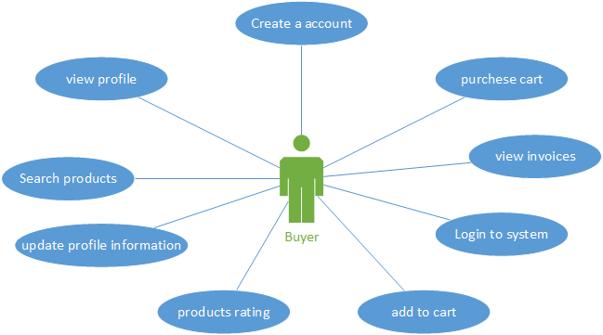

## Admin

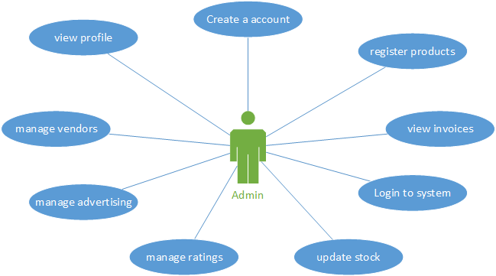

## Super Admin

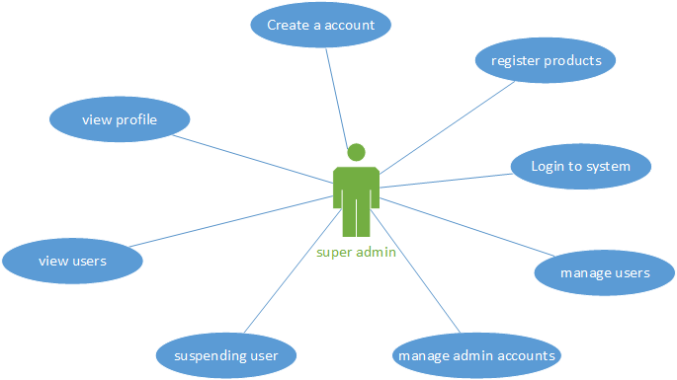

## Advertiser

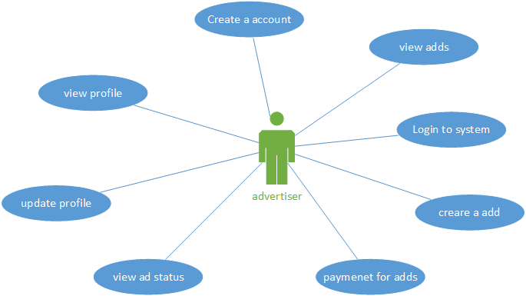

# Activity Diagrams

## User Registration

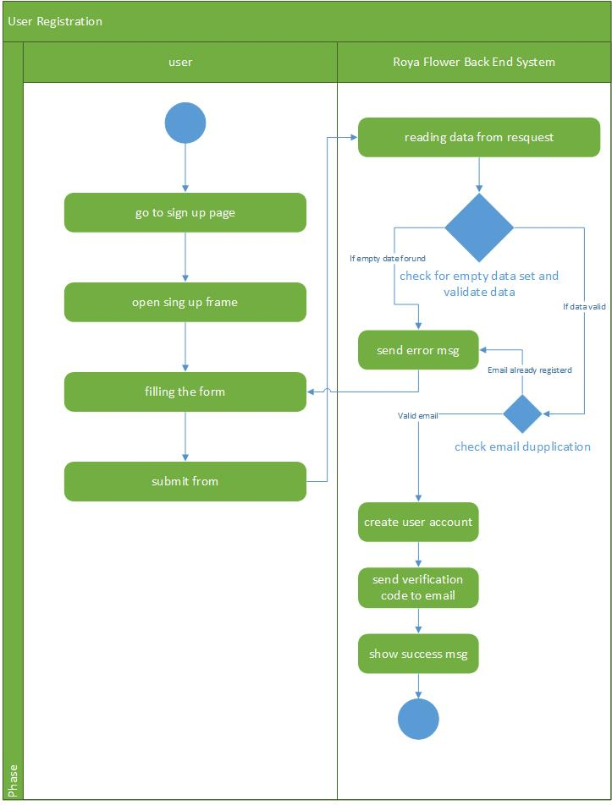

## Account Activation

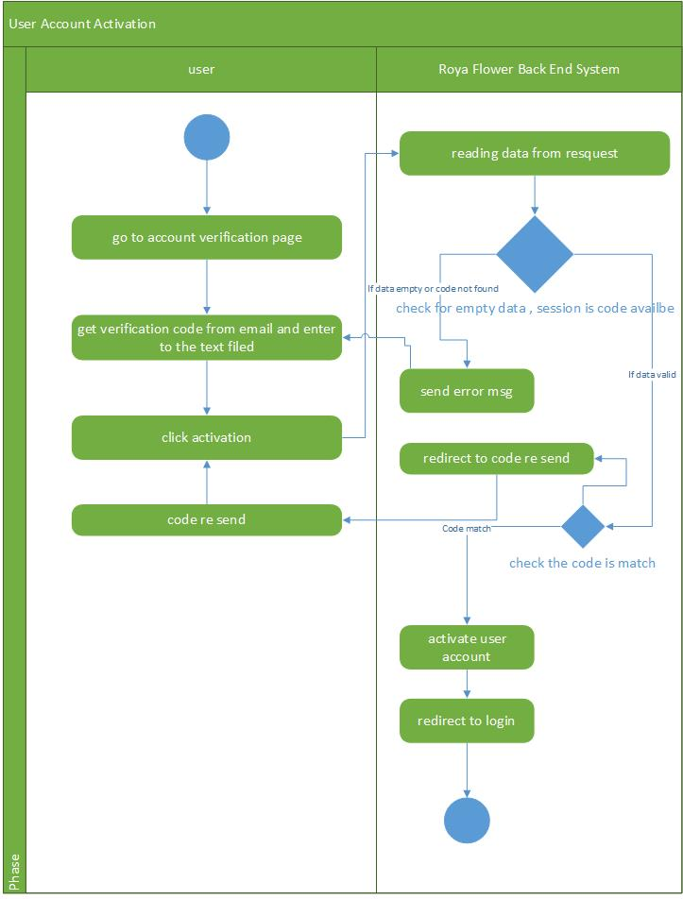

## Search Product

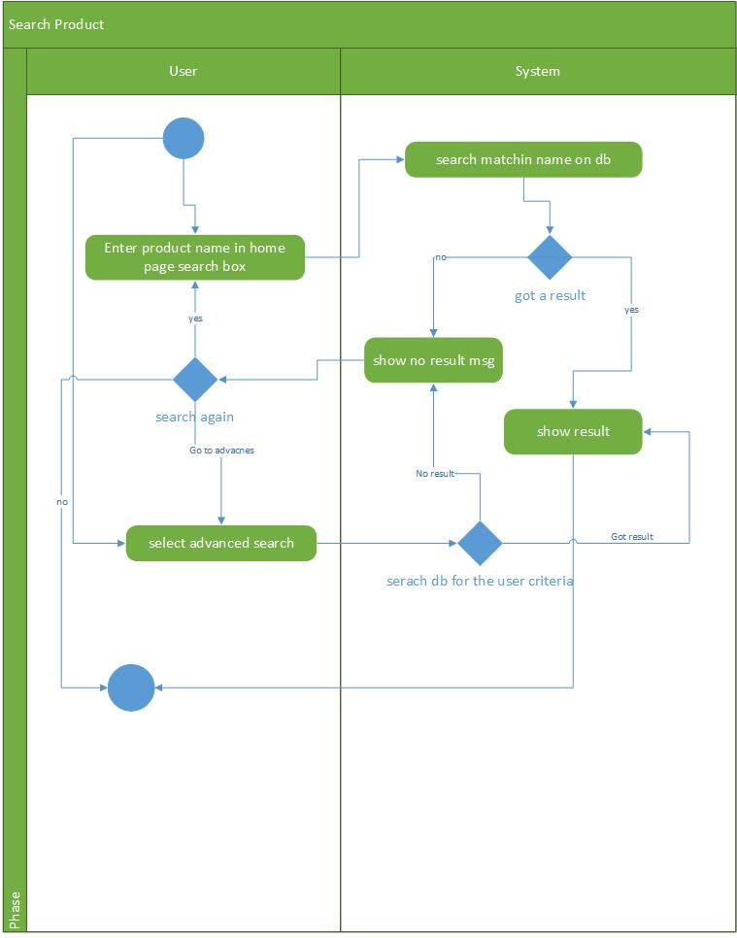

## Product Rating

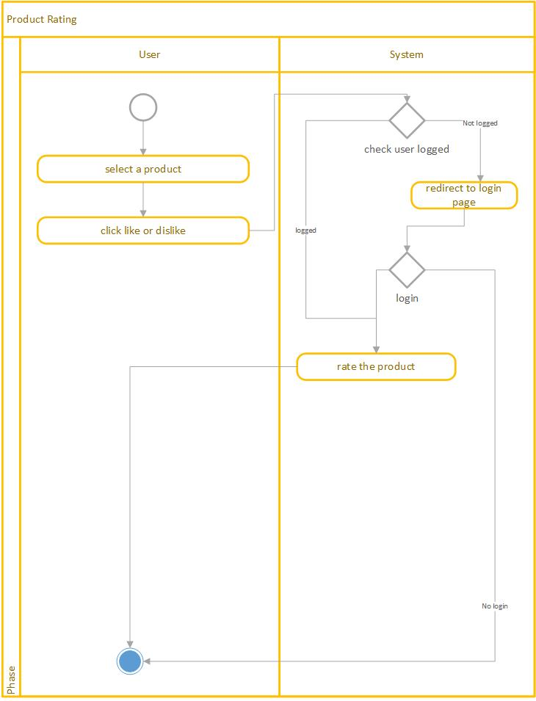

## Add to Cart

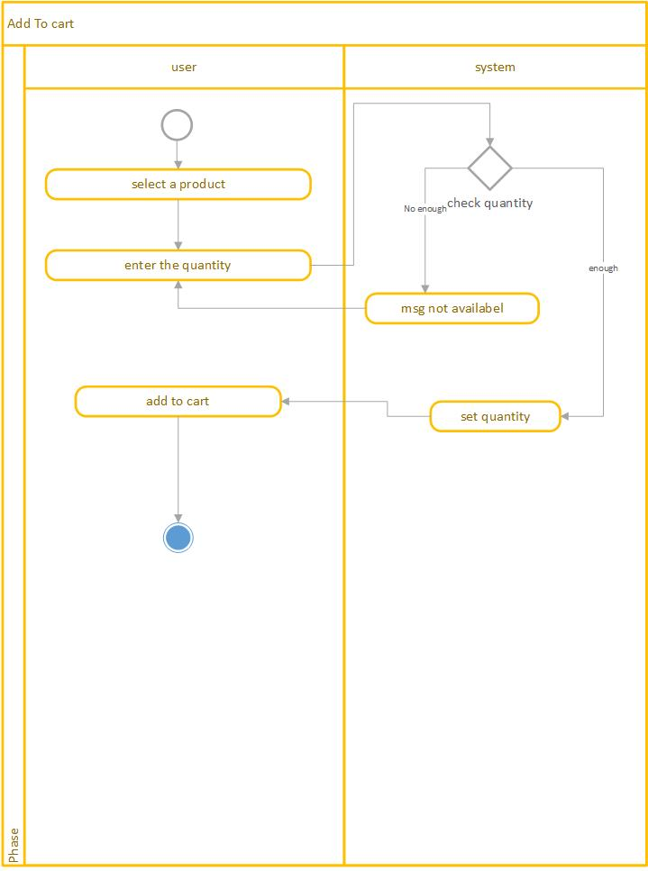

## Purchase Cart

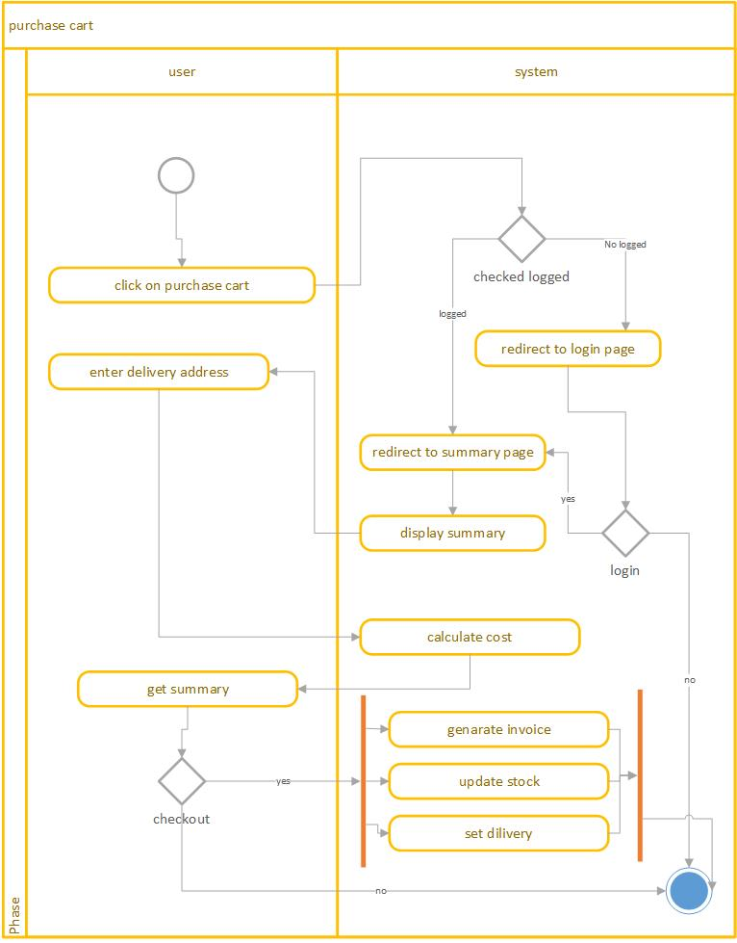

## Product Reorder

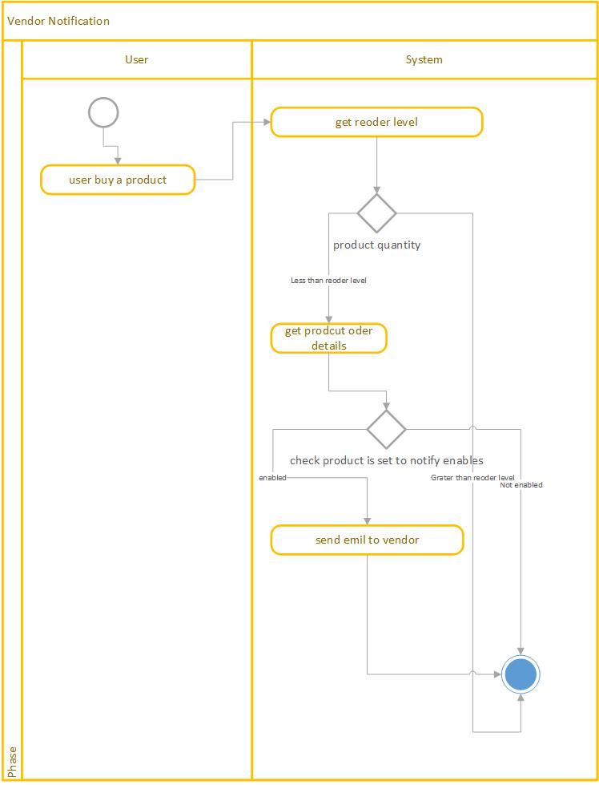

# Interfaces

## Home

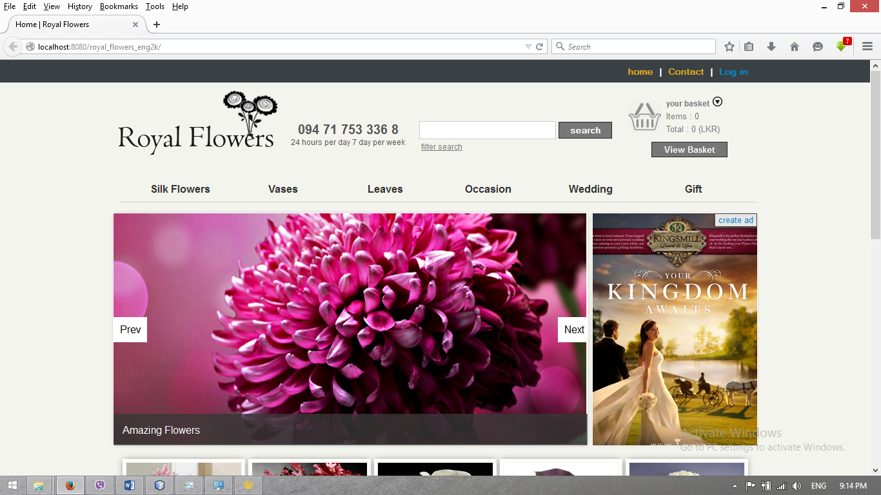

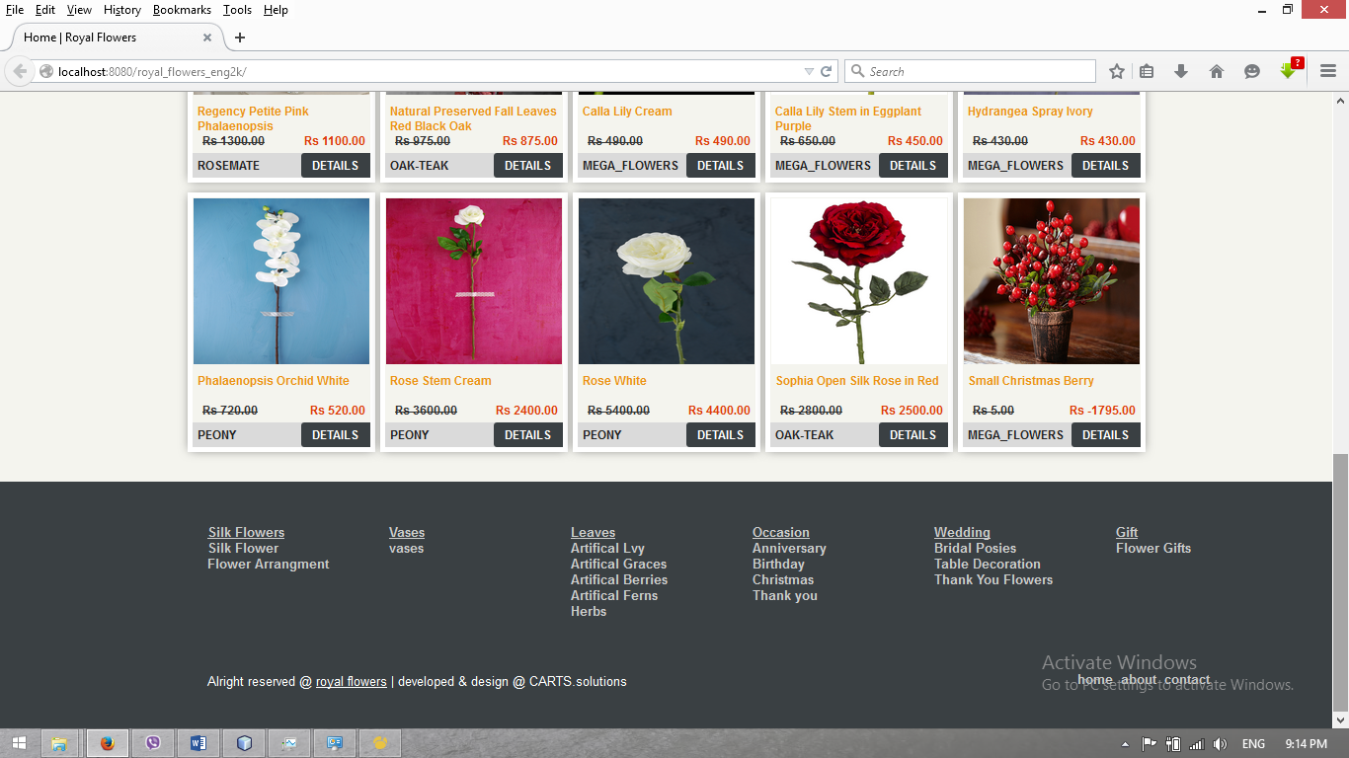

## User Registration

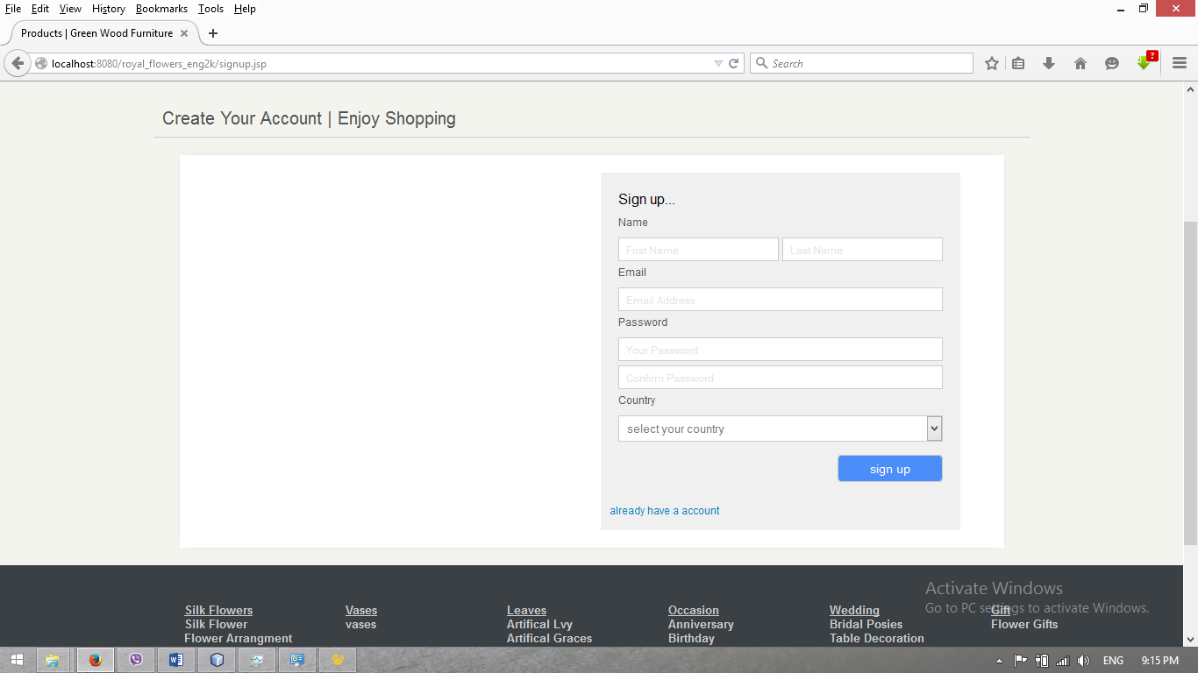

## Login

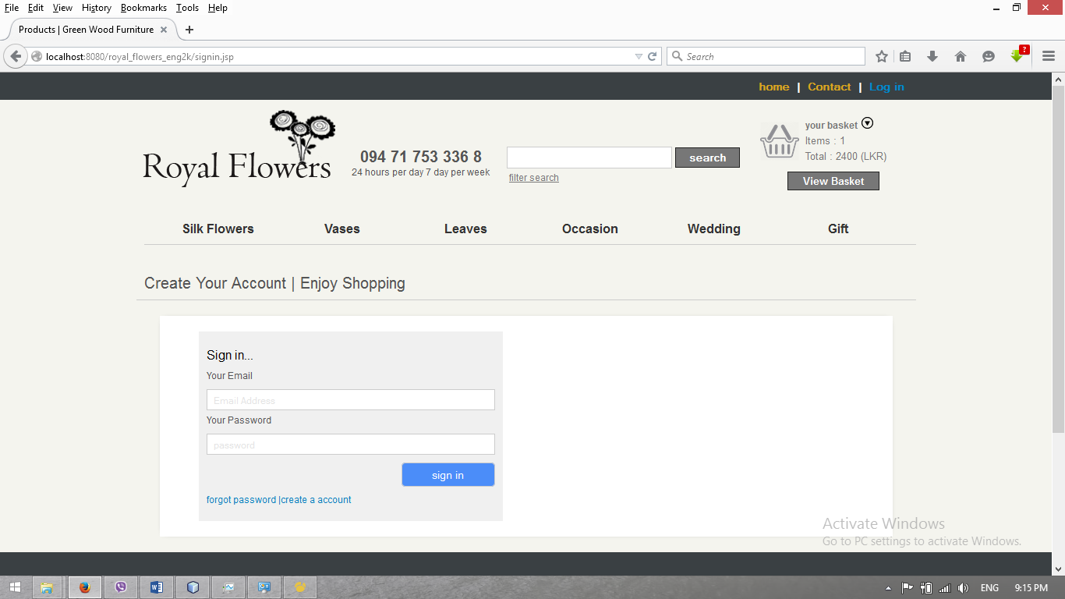

## Product Details

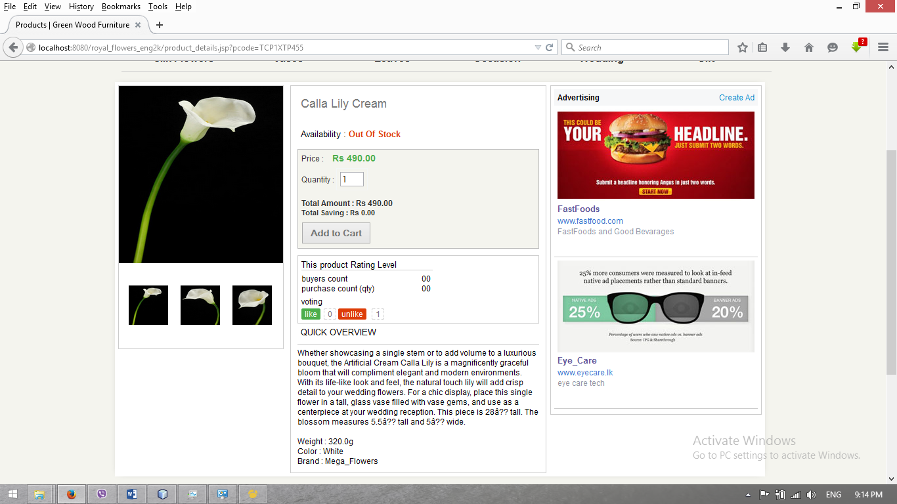

## Account Verification

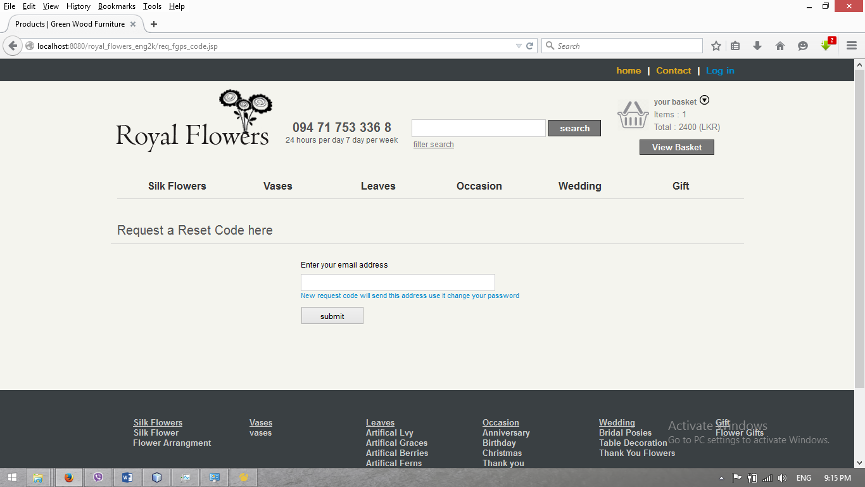

## Cart

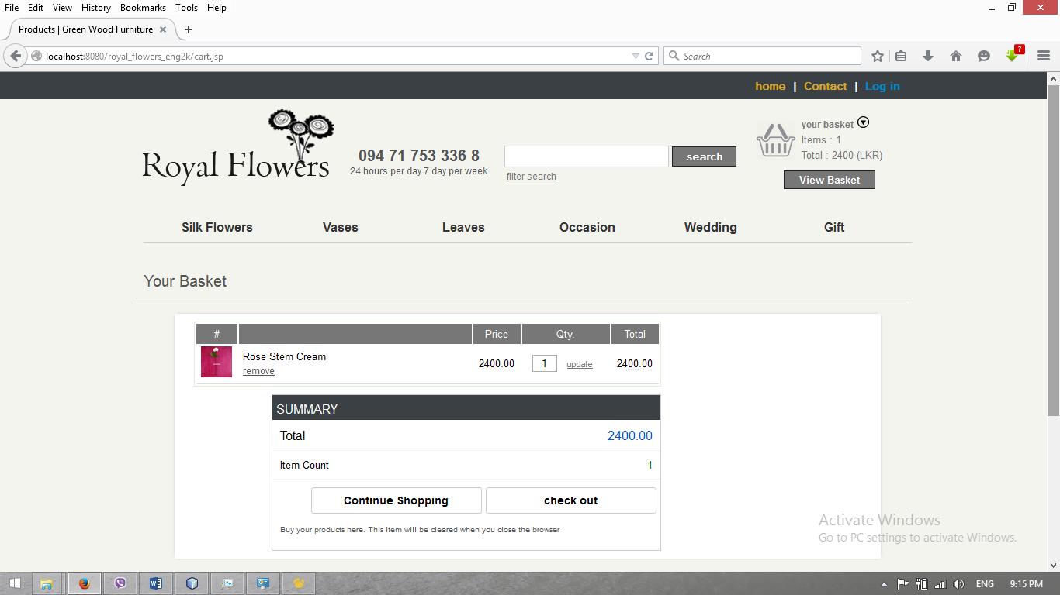

## Search & Advanced Search

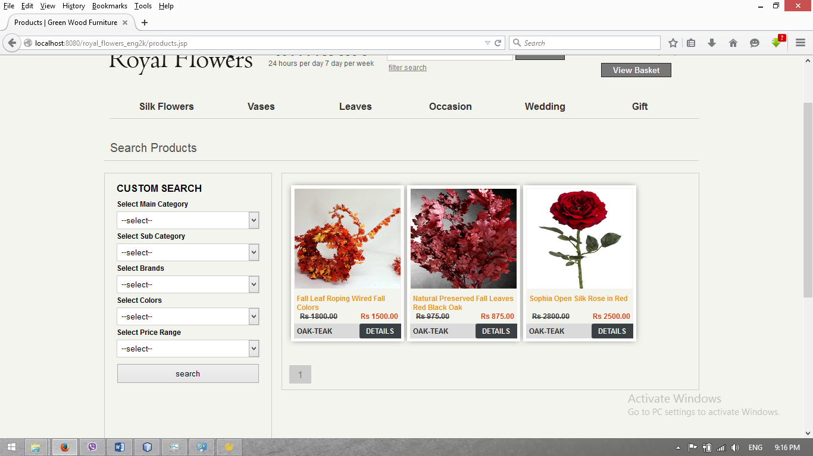

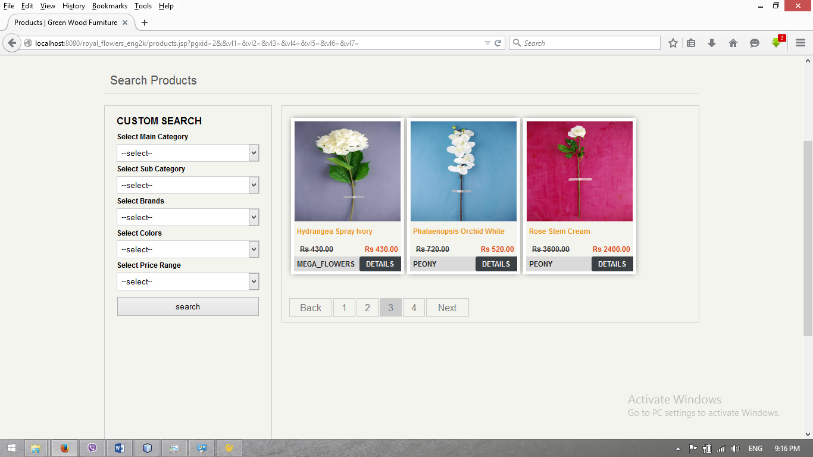

## Purchase Summary

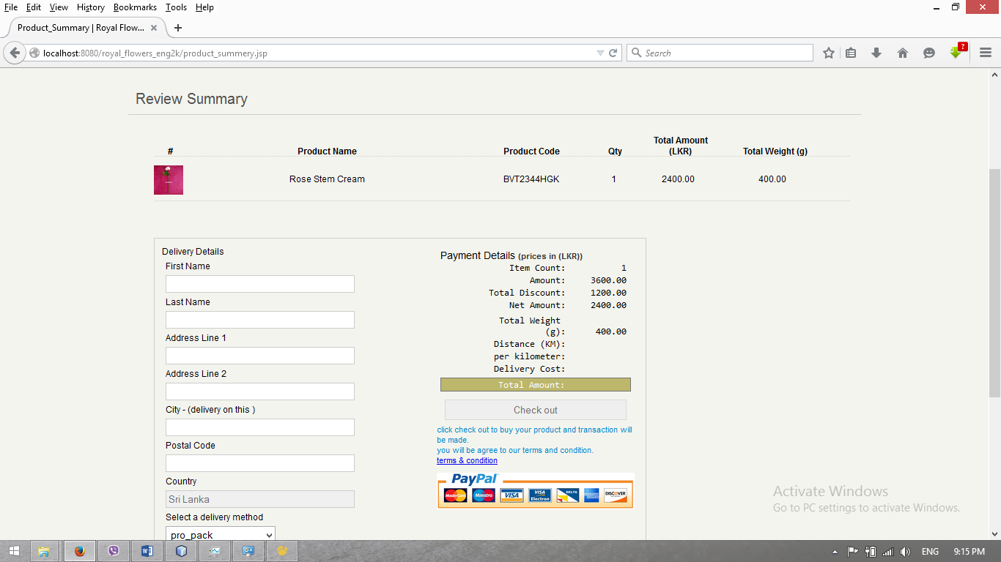

## Profile

### Basic information

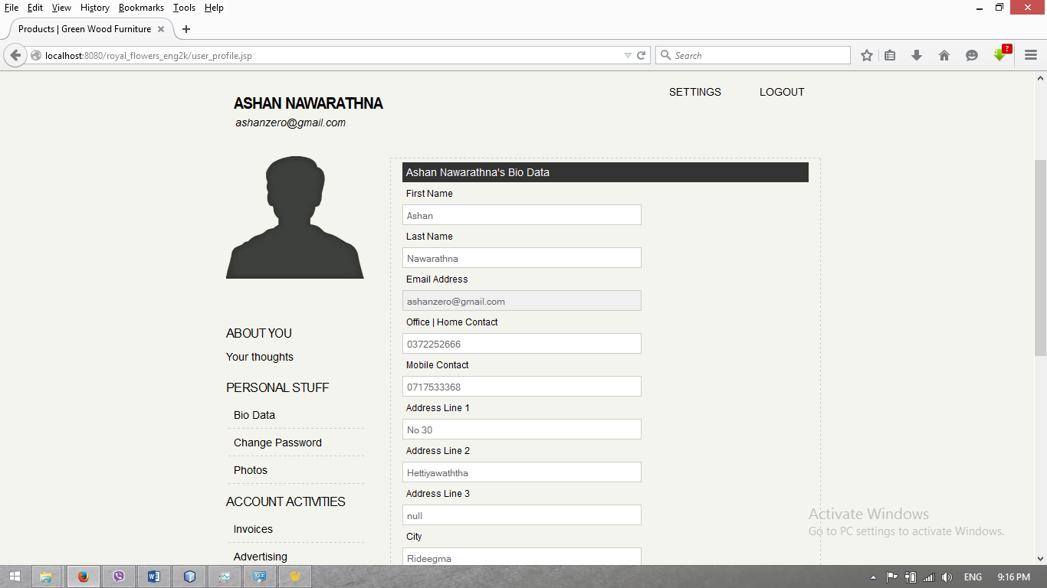

### View Invoice

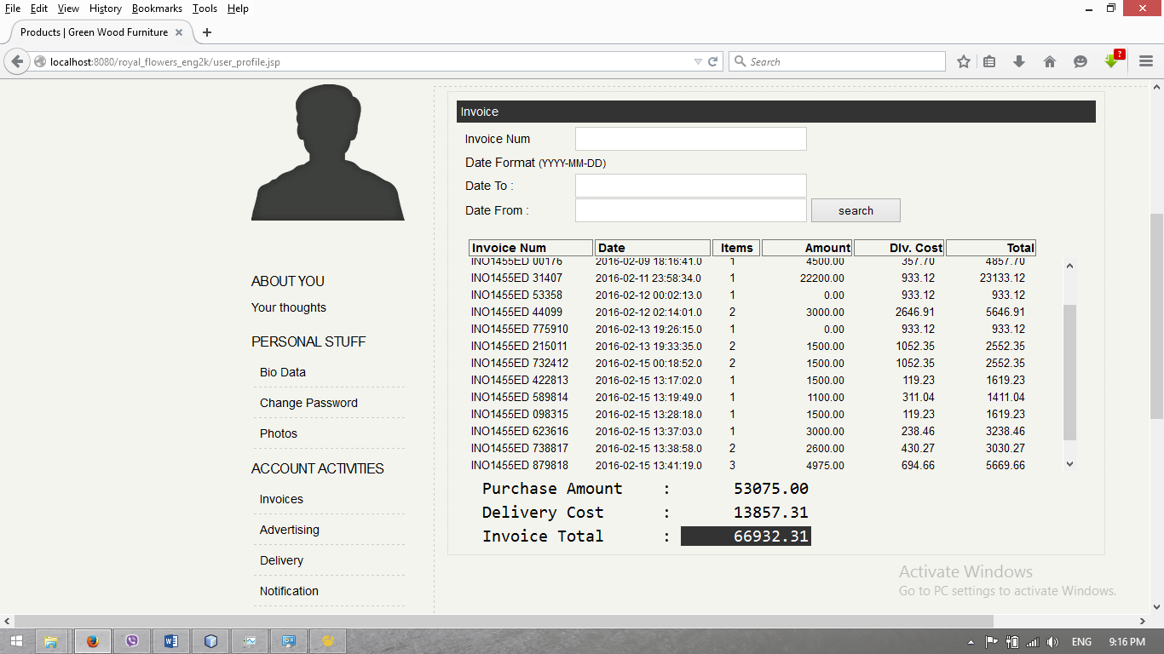

## Admin Panel

### Product Registration

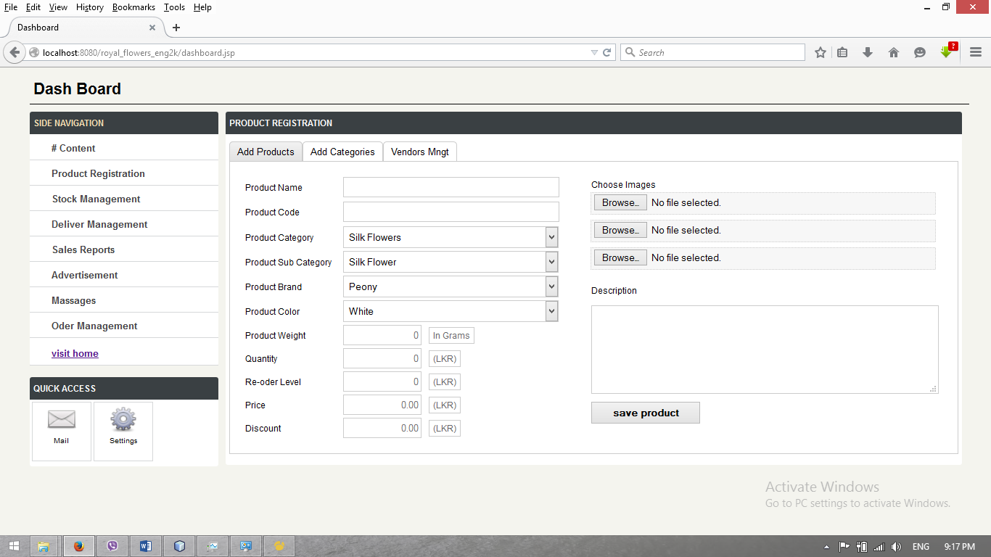

### Vendor Management

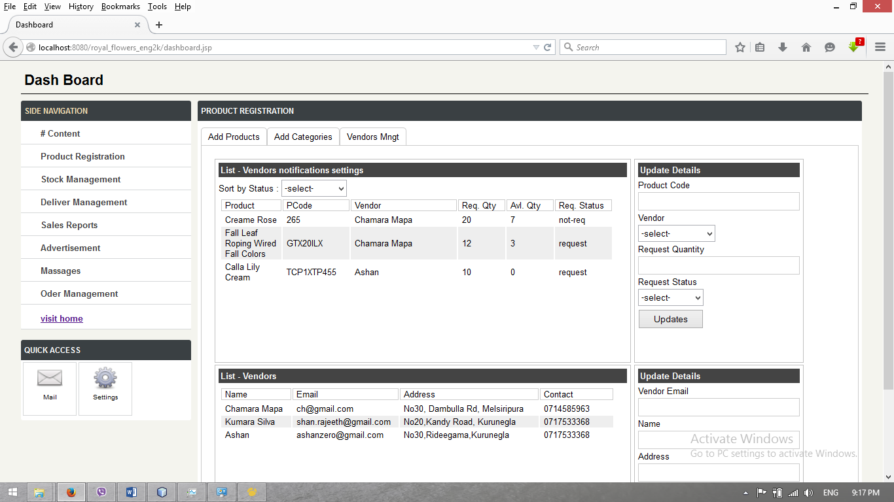

## Advisors

### Create Ads

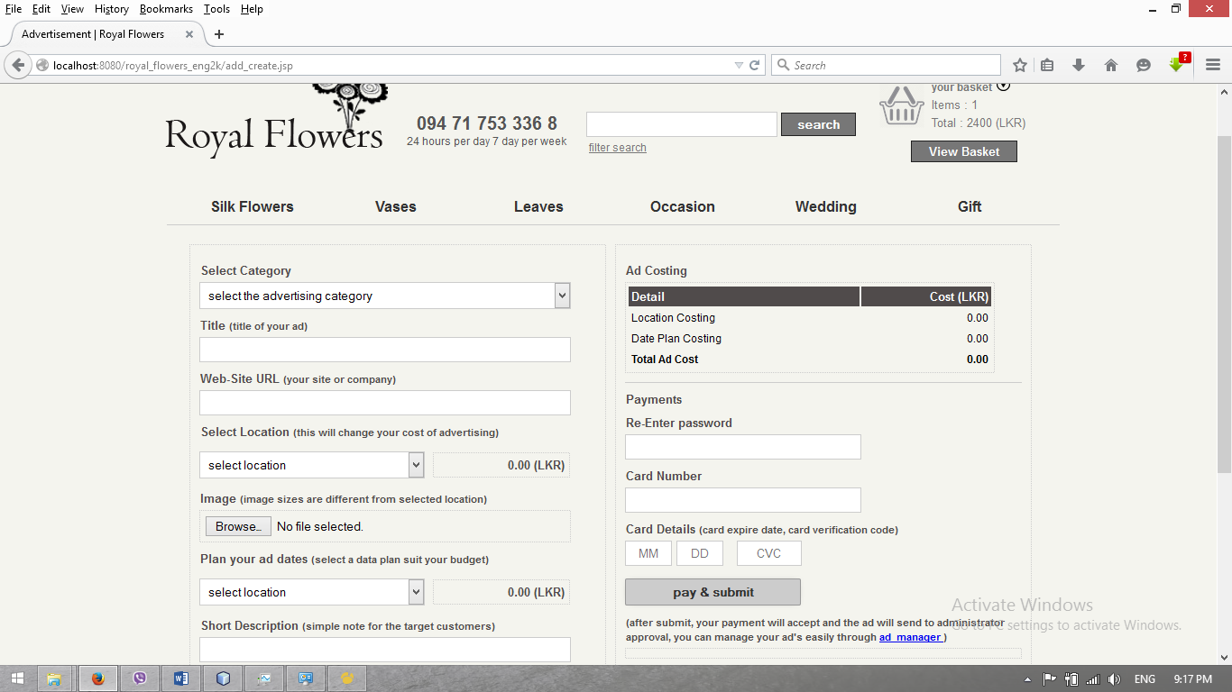

### View Ads

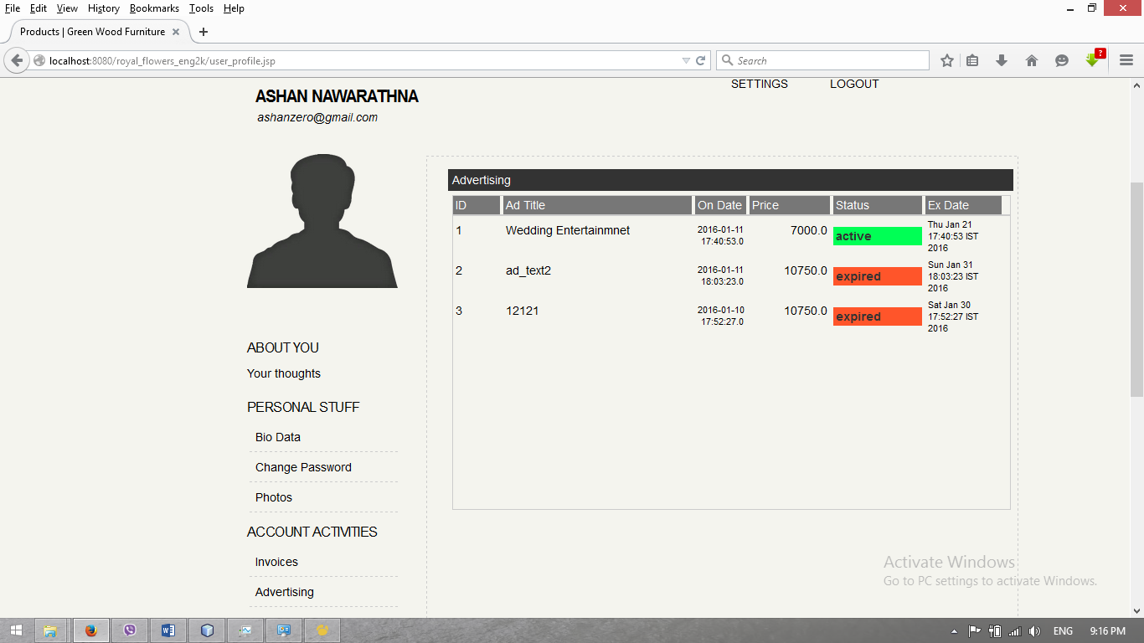

### Stock Management

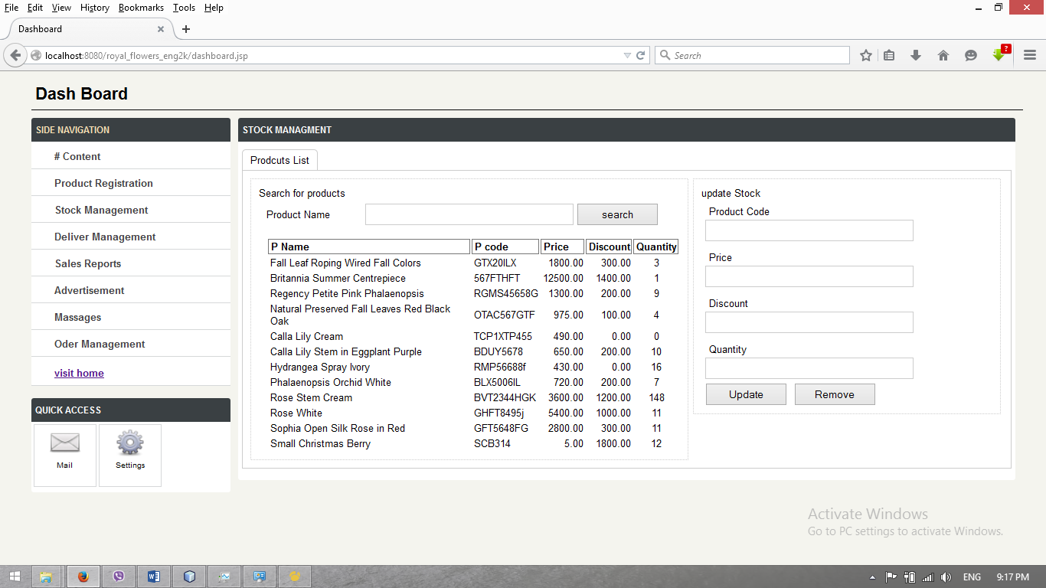

### Advertisement Management

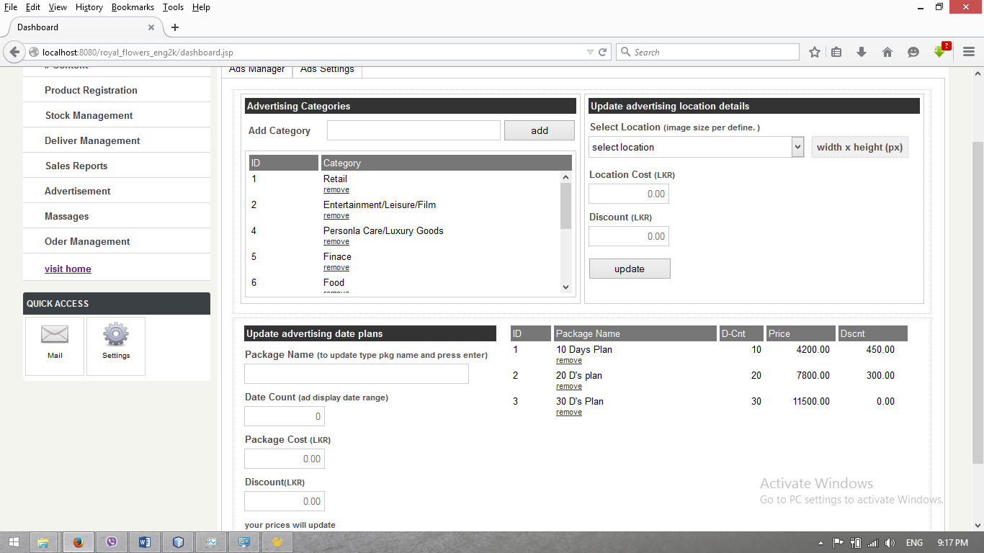

# Entity Relationship Diagram

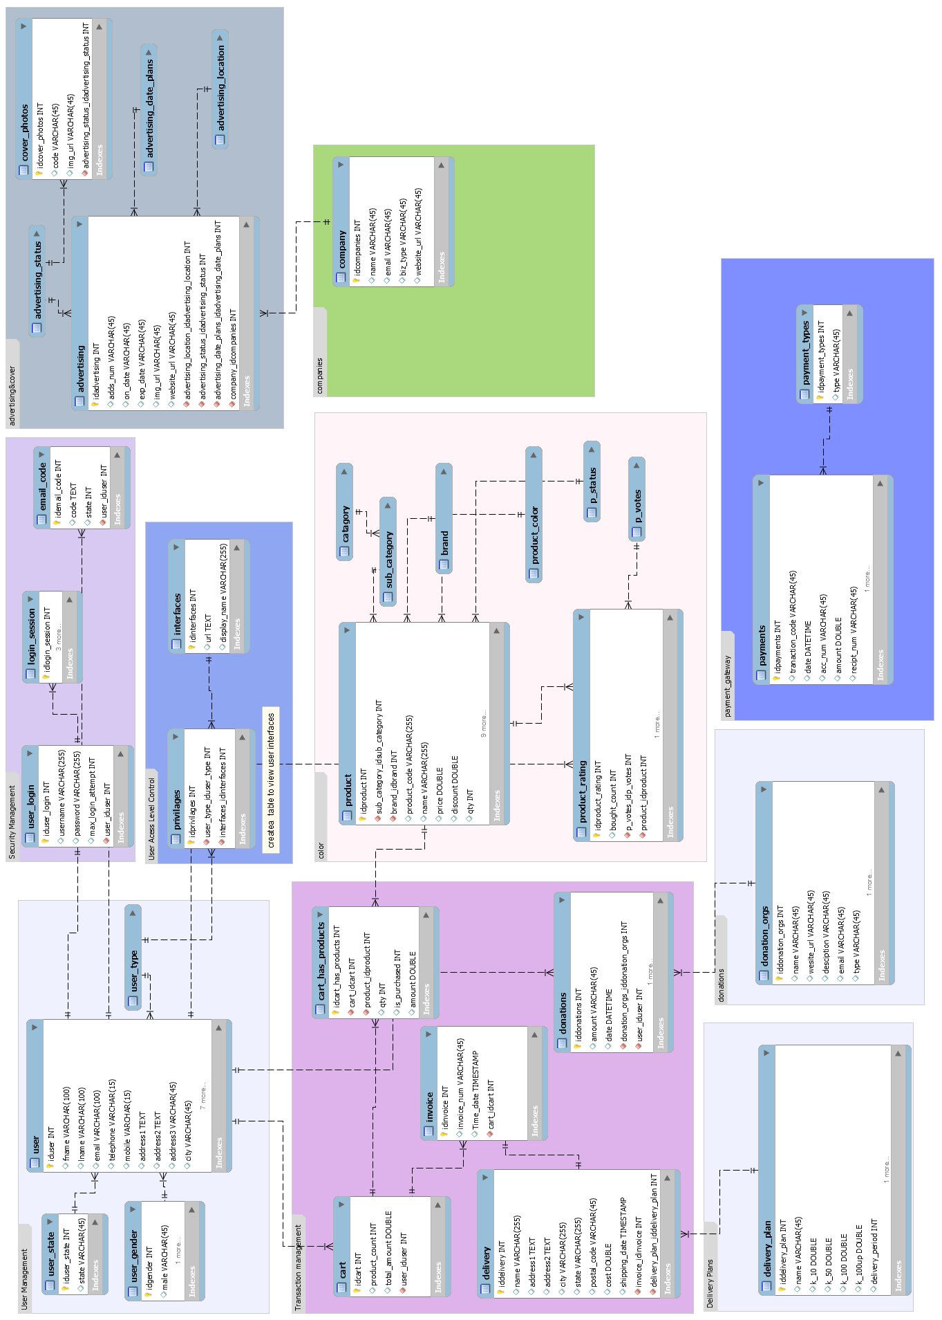

Ashan Nawarathna .  
930660671v | 0717533368.

AJD_ES Final Project – Royal Flowers